BOOK PUBLISHING CO.

ISBN 978-1-57067-226-2 Contact: Anna Pope
$14.95 160 pages Sept. 2008 annap@bookpubco.com

Drop the Pounds – Double the Energy

The Double Energy Diet shows how you can lose weight gradually and permanently while simultaneously boosting your energy to new heights. Authors Shari and Judi Zucker, known as the “Double Energy Twins”, exude an abundance of energy and enthusiasm and exemplify the lifestyle they promote.

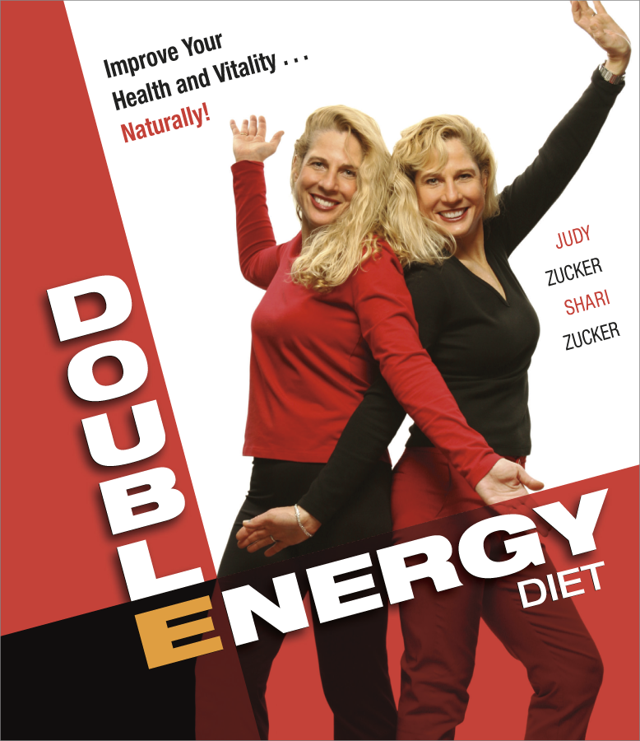
Endorsed by doctors and fitness experts, The Double Energy Diet is based on smart, practical information that can improve your health and increase vitality. Their program, based on life-enhancing natural foods, allows you to:

- attain a healthy weight and fulfill all nutritional needs
- reduce the amount of fat in your meals
- save time and money spent in the kitchen
- satisfy both physical hunger and psychological cravings
- use less resources and leave a smaller eco imprint

All without sacrificing enjoyment of your favorite foods. Over
70 delicious, easy-to-prepare meatless recipes showcase real food with fresh tastes, textures and colors ~ including pizza, potato salad, and eggplant parmesan. Moderation becomes second nature and old behaviors and eating patterns disappear with the pounds.

The strategies and recipes outlined in The Double Energy Diet prove that it
is never too late to rejuvenate and get in tune with your body.

The Authors: Judi and Shari Zucker wrote their first cookbook, How to Survive Snack Attacks …Naturally, when they were just seventeen. They graduated with honors in ergonomics, the study of human physiology, physical education, and nutrition, from the Univ. of California, Santa Barbara. Judi and Shari enjoy successful careers in real estate and interior design as well as creating and compiling recipes for nutritious low-fat, high fiber meals. Both are married with families. They also wrote How to Eat Without Meat…Naturally and Double Your Energy with Half the Effort.

PO BOX 99, SUMMERTOWN TN 38483
PH 931-964-3571 info@bookpubco.com Fax 931-964-3518

