
FOR IMMEDIATE RELEASE
Contact Info: Anthony Pomes, VP – Marketing/PR/Rights
www.SquareOnePublishers.com
Phone: 516-535-2010 x 105

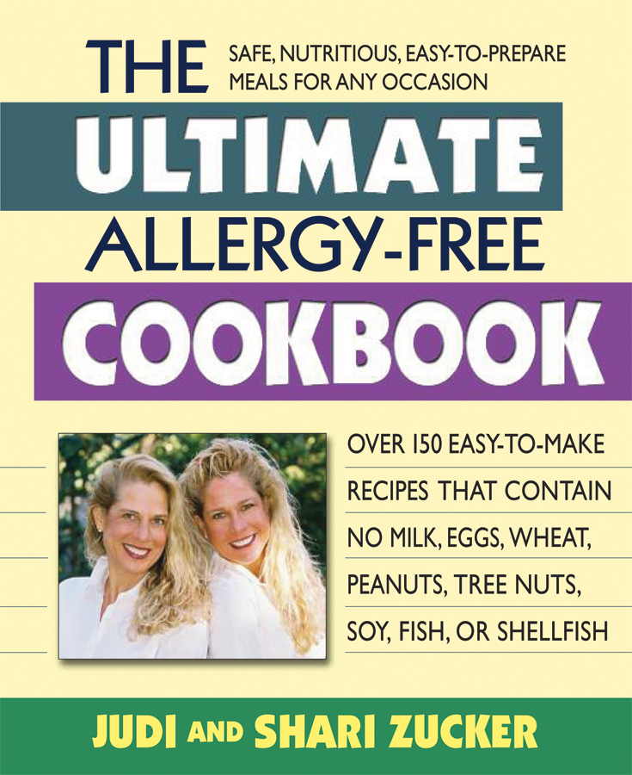
Food Allergies
Never Tasted This Good!
From the “Double Energy” twin-sister bestselling author team of Judi & Shari Zucker comes a new book of over 150 delicious, easy-to-make and allergy-free recipes that are a perfect match with the Zuckers’ first book all on yummy allergy-free snacks

For too many people, the term “allergy-free cooking” conjures images of bland and boring meals—dishes that seem to be “missing something.” But the fact is that meals can be made flavorful, satisfying, and healthful, and still eliminate common allergenic foods. The Ultimate Allergy-Free Cookbook—already declared by Publishers Weekly “a useful resource for the recently diagnosed and/or parents of children with allergies”—will show how.

Written by bestselling authors Judi and Shari Zucker (pronounced “Zucker as in Cooker”) as the enthusiastic follow-up to their mega-popular previous book The Ultimate Allergy-Free Snack Cookbook, this new title provides over 150 delectable vegetarian/vegan recipes that are made without eggs, cow’s milk, soy, wheat, peanuts, tree nuts, fish, or shellfish—the eight most common allergenic foods according to the US Food and Drug Administration. (They are also free of gluten and refined white sugar.)

In their new book, Judi and Shari also provide their readers with the following:

* Easy-to-follow step-by-step recipe instructions
* Guidelines for setting up an allergen-free kitchen
* Instructions for reading food labels
* Tips for avoiding cross-contamination
* List of allergen-free ingredient options
* Resource Section With Both Helpful Allergen-Free Websites and Easy-to-Find Products

This truly is the ultimate allergy-free cookbook. It doesn’t matter which of the top allergenic foods you must avoid, or if the allergy is mild or severe. You can serve all of the delectable dishes in this book without fear of a reaction. Best of all, the recipes are not just for those with allergies—they will delight everyone in your family. So enjoy!

To learn more about Judi and Shari Zucker and to view their national-TV appearances on shows such as NBC’s Today, Better TV’s The Better Show, and Hallmark Channel’s Home & Family, feel free to visit their website at www.doubleenergytwins.com.

Please feel free to contact me in order to receive a review copy of The Ultimate Allergy-Free Cookbook, along with press materials. Thank you for your time and consideration.

BOOK SPECS: $15.95 ($19.95 CAN) / 192 PGS. / ISBN: 978-0-7570-0397-4 / 7.5 x 9-INCH PAPERBACK

115 HERRICKS ROAD GARDEN CITY PARK NEW YORK 11040

